**User Manual**

OCTa_data_extraction By Hao Ho

Lion Eye Institute

Introduction …………………………………………………………………………………………………………………………

Instructions…………………………………………………………………………………………………………………………..

Notes …………………………………………………………………………………………………………………………………..

# Introduction

OCTa_data_extraction program is to be used to extract data from am OCTa readout (png) file to an excel spreadsheet. This document shows how to use it step by step.

# Instructions

1. Make sure the folder is set out like below.

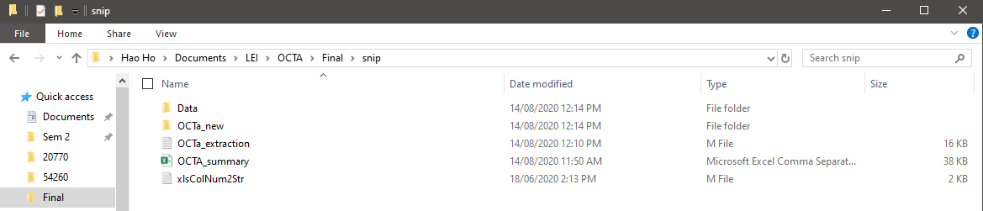OCTa_extraction.m file is in the same folder as data (folder containing patient’s folders – example shown below), OCTa_new, OCTa_summary.csv, xlsColNum2Str.m.

Data folder layout.

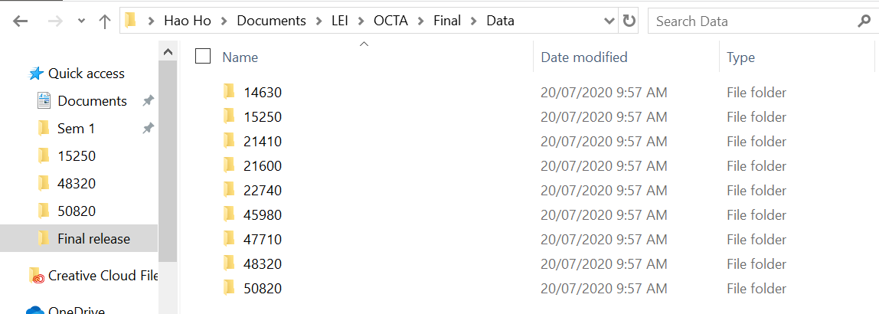

OCTa_summary.csv is where the values will be written to. It requires the headings to already be written in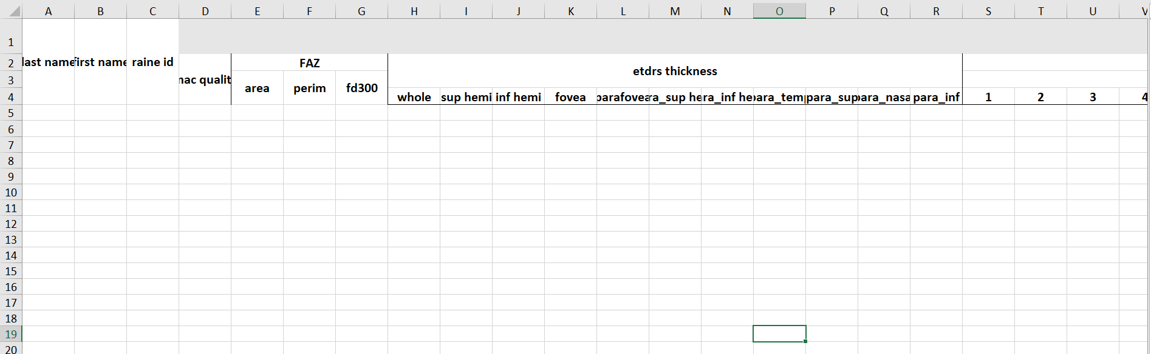.

OCTa_new contains the trained program that will be used to read the png.

1. Launch MATLAB via VMware and a popup will show asking for access to local files. Click allow

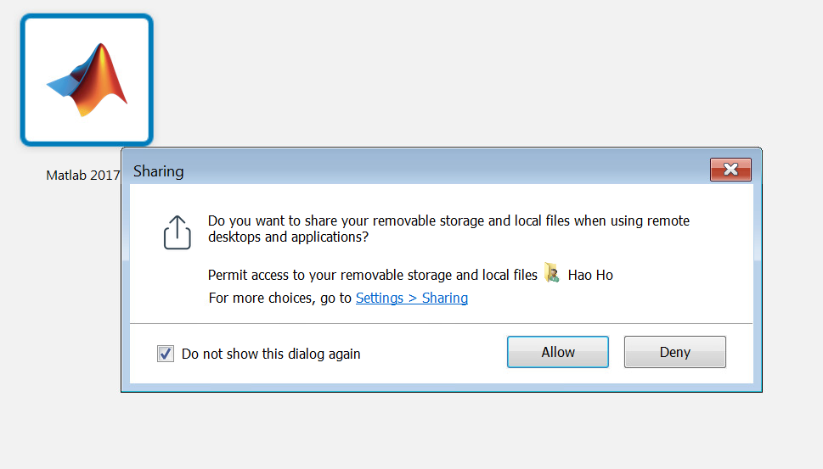

1. Change the current folder stream to the folder with OCTa_extraction.m.

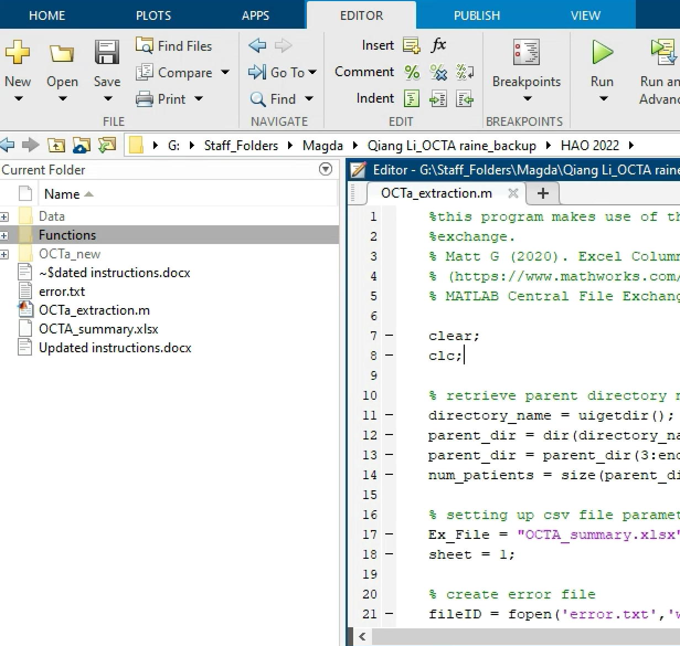

Click browse for folder and select the folder that has the program i.e “HAO”

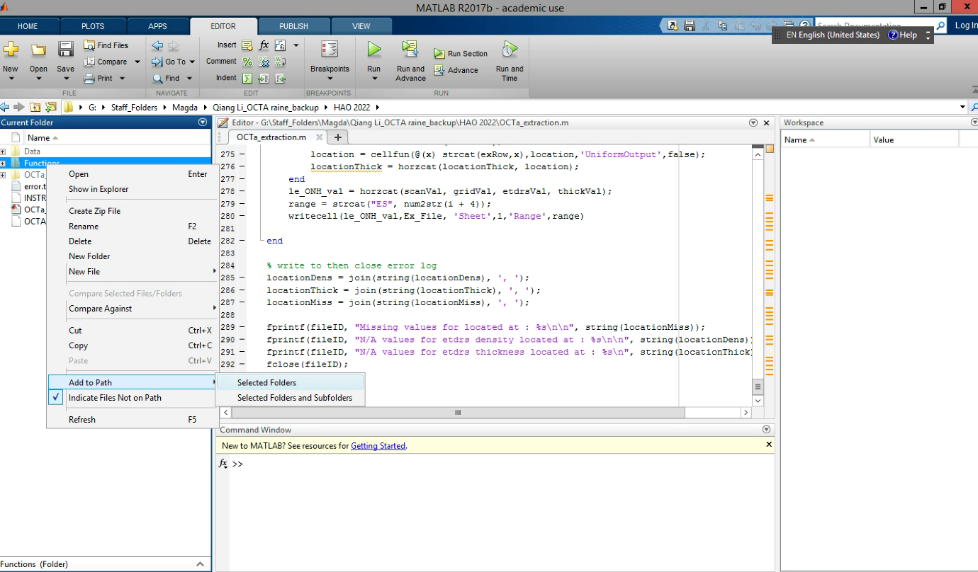

4. Enable the function script prior to running the extraction protocol. Right click on the “Function” option and navigate down to “Add to Path” at the bottom of the list. Hover over “Add to Path” until secondary options become available. Click on “Selected Folders”

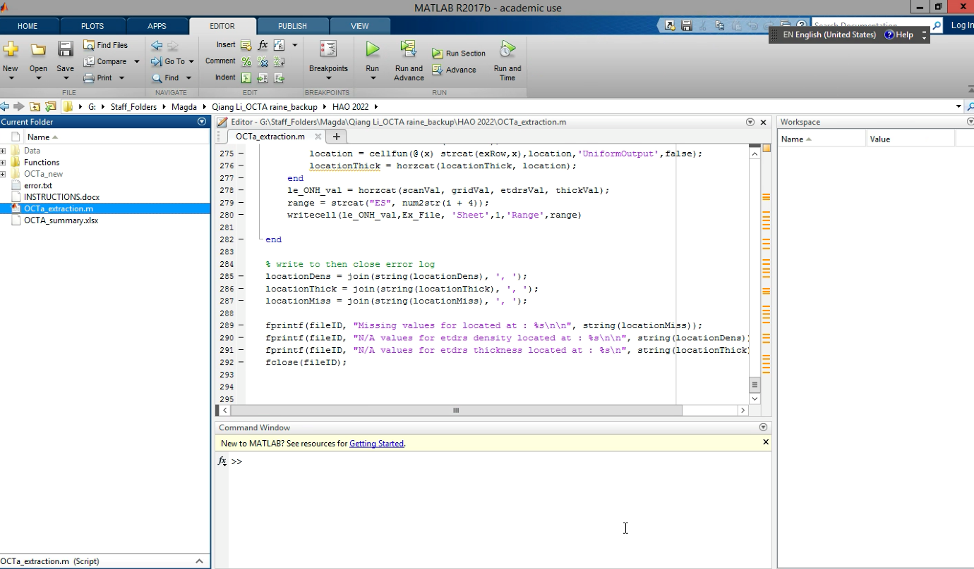

5. Enable the OCT-A extraction protocol by clicking on the file. Wait for text to appear/be input by MatLab.

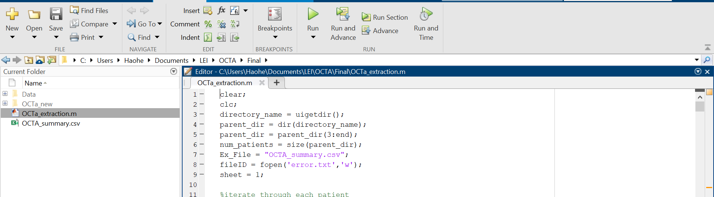

6. Press run

7. Select the data file when prompted. Make sure folder says Data.

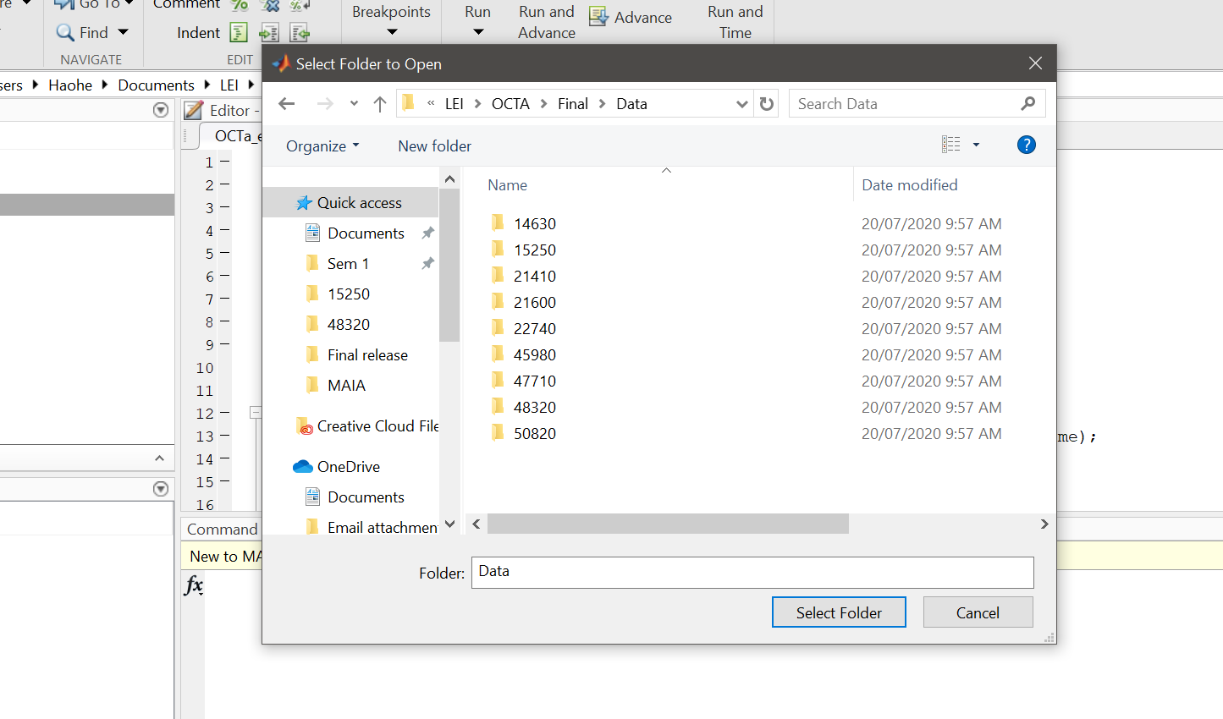

8. Values will be written into the existing excel file (OCTa_summary.csv).

9. A text file (error.txt) will appear that will contain any missing values in the excel file.

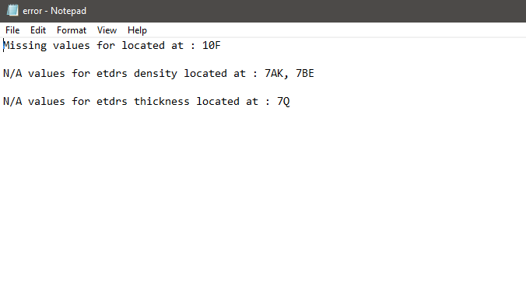

# Notes

* This program makes use of a function found on MathWorks exchange.
* Matt G (2020). Excel Column Number To Column Name (https://www.mathworks.com/matlabcentral/fileexchange/15748-excel-column-number-to-column-name), MATLAB Central File Exchange. Retrieved August 14, 2020.
* Error log will report 3 type of invalid values found
* Missing values: These are values that could not have been read resulting less values then expected. When this occur error will show the exact location of missing values (FAZ values) or show the start of a row of missing values (grid, etdrs, thick). If a value is missing from grid, etdrs or thick, the affected section will be replaced by empty spaces for manual input.
* N/A density and thickness: These are values for density or thickness that were below a confidence of 0.55 (typically “N/A”). The excel location will be replaced by “N/A” and the exact location will be in the error report manual checking.